Car Rental Database Application
Background:
Car rental system has done by method for the client register by telephone or come straightforwardly to the workplace for registering for rental procedure, so it took a great deal of time and assets required is additionally expanded on the grounds that every procedure requires diverse assets. The organization has attempted to set up the rental framework well. In any case, because of confinement manual framework and just controlled by a few groups inside the organization, accordingly causes the current report information gets to be hard to oversee. An organization occupied with the car rental requires a rental application framework that can coordinate the traditional rental toward the idea of online rental. The idea poured on online web auto rental upheld with the capacity to relentless access.
ERD Diagram:
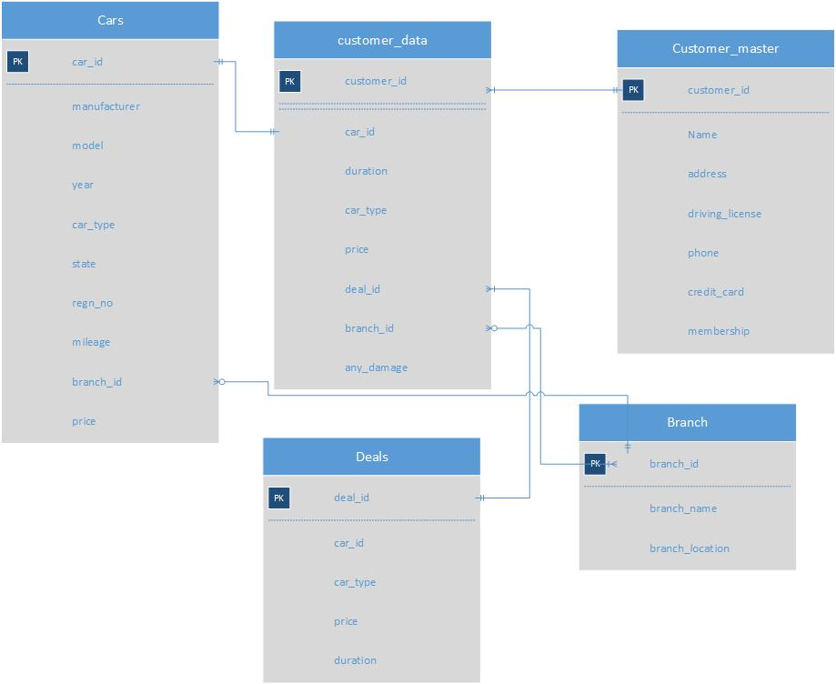

Entities:
Various entities according to the requirement are as following:
1. Branch branch_id, branch_name, branch_location
Primary key branch_id
2. Cars car_id, manufacturer, model, year, car_type, state, regn_no, mileage, branch_id, price
Primary key car_id
Foreign key branch_id (branch)
3. Customer_mastercustomer_id, name, address, driving_license, phone, credit_card, membership
Primary key customer_id
4. Deals deal_id, car_id, car_type, price, duration
Primary key deal_id
Foreign key car_id (car)
5. Customer_dataid, car_id, duration, car_type, price, deal_id, branch_id, any_damage
Primary key id
Foreign key branch_id (branch)
Foreign key car_id (car)
Foreign key deal_id (deal)

Data Definition Statements:
1. Branch:
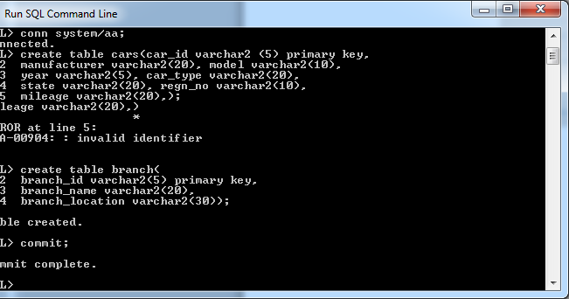
2. Cars
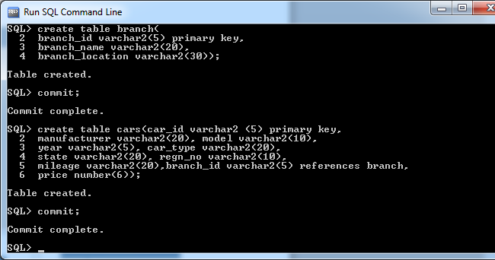
3. Customer_master
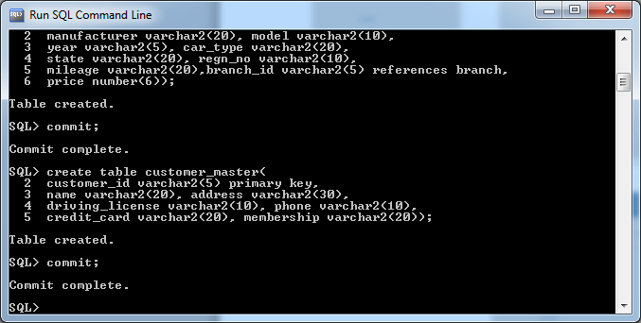
4. Deals
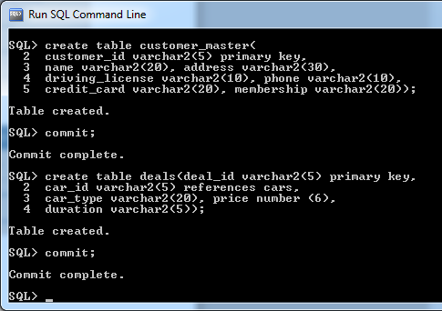
5. customer_data
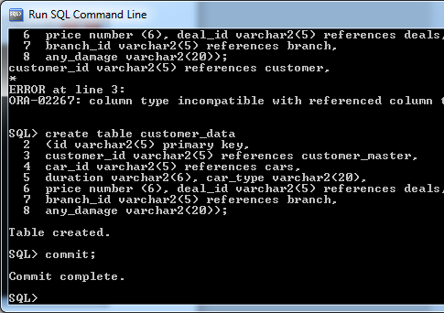

Inserting Data:
1. Branch
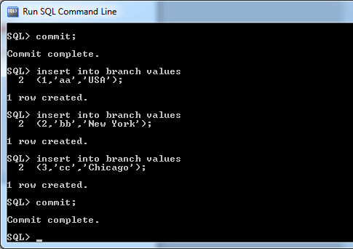
2. Cars Table
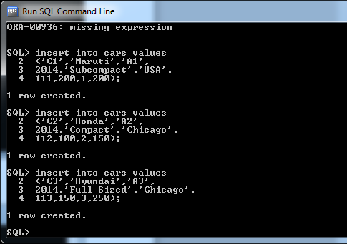
3. Deals
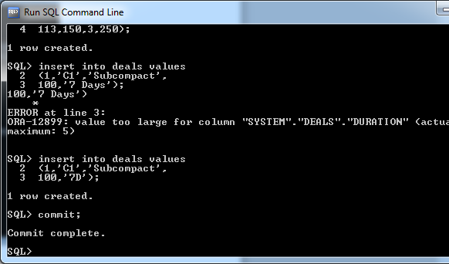
4. customer_master
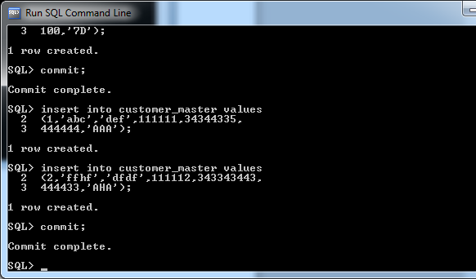
5. Customer_data
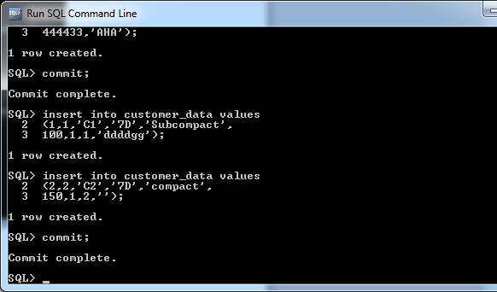
Queries

To display the car rental history of a particular (pick any) customer
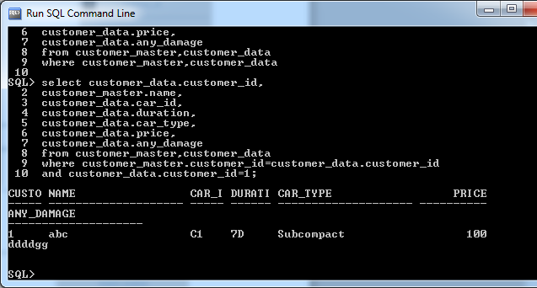

Auto recovery command
1. mysqlcheck
The mysqlcheck command is used to performs table maintenance: It checks, repairs, optimizes, or analyzes tables.
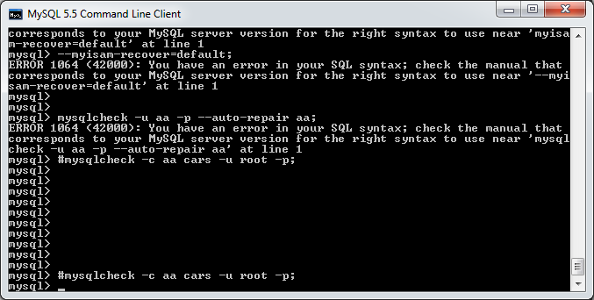
Database name aa
Table - cars
2. Text Backups:
mysqldump is the command-line client command which is used to backup local or remote MySQL database or collection of databases for backup into a single flat file.
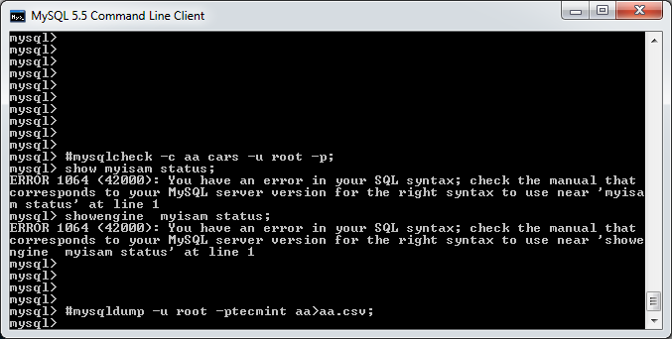
3. Recovering the entire database:
A full recovery restores all information from a full backup. This restores the server example to the state that it had when the backup was made. In the event that that state is not adequately present, a full recovery can be trailed by recovery of incremental backups made subsequent to the full backup, to convey the server to up to date state.
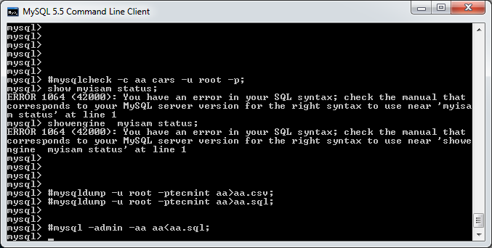
4. Auto recovery command
It automatically recovers the entire database
